**Introduction**:

I analyzed **Amazon Prime** video data and provided insights about the analyzed data based on the business need.

**Data Preparation**:

Before providing Exploratory Data Analysis, we have to decide what are the features required for **EDA**. After selecting the required features, we have to check if the dataset contains missing values, Null values etc. If there are any NULL values in the dataset provided, we replace it with the required variables or values. Then, we have to go through if there are any duplicate rows present in the dataset. In this dataset there are three duplicates, in which it does not affect the overall distribution of the dataset.

**Data Analysis and Visualization:**

After data preparation, we analyze the data provided, by comparing the Release years and and Count, the histogram shows that 2020 has the maximum number of counts.

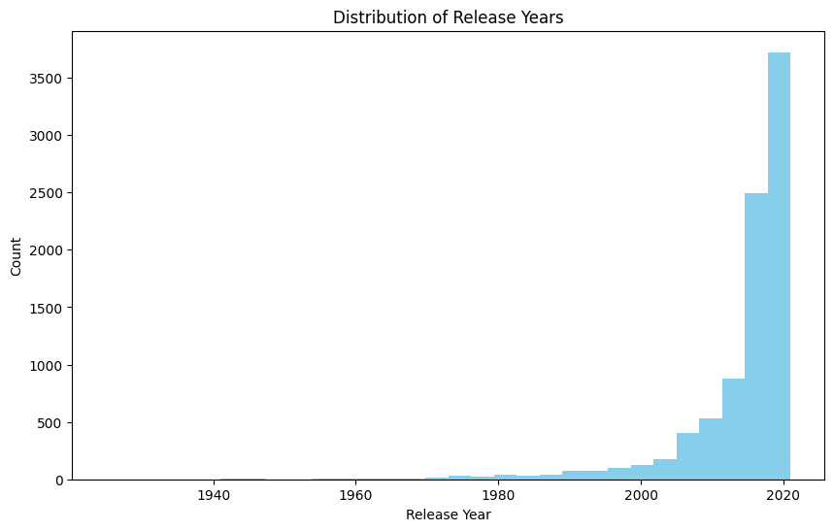

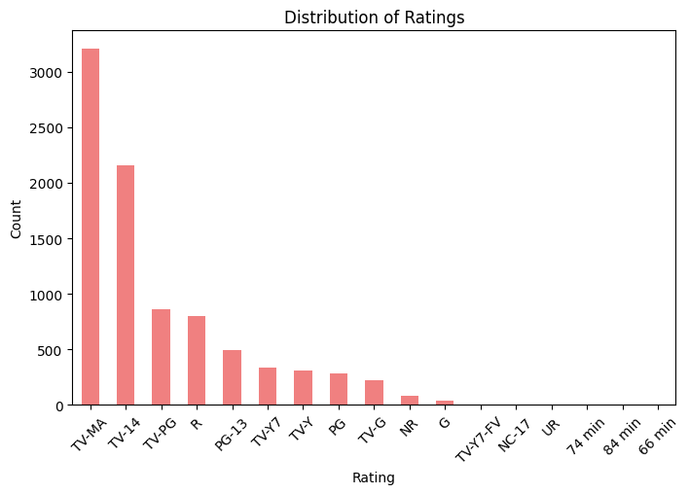

Next, by comparing the Rating and Count, the bar plot shows that TV-MA has the maximum count.

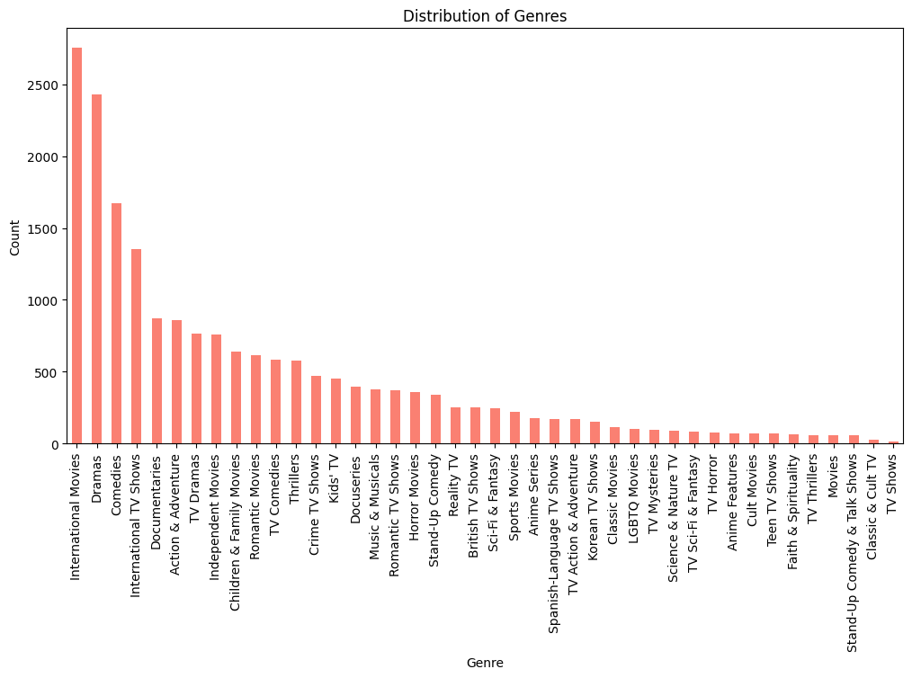

Next, by comparing the Genre and Count, the bar chart shows that International movies have maximum count.

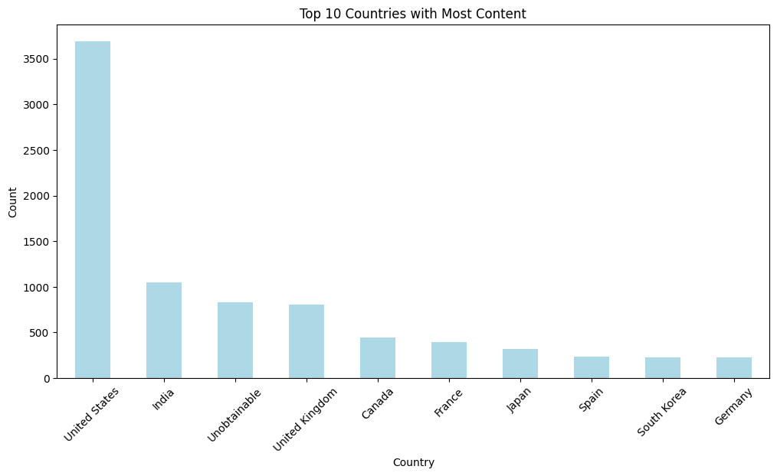

Finally , by comparing the Country and Count Features we can see that, United States has the highest counts among other countries.

In conclusion, 1. Amazon Prime released uploaded more shows in 2020

2. Amazon Prime uploads more Movies than TV Shows

3. The most uploaded shows on Prime video are from the US.